  - WEEK 1

VACS AI Patient &
Grading Issue Report
  - Consolidated Clinical and Operational Audit
Tuesday • Wednesday • Thursday
MG → JW → LM

Prepared by
Mitchell Bowers
PharmD Candidate, Class of 2027
D'Youville University School of Pharmacy
Report date: October 6, 2026

Purpose: Consolidate the nine supplied Week 1 initial audits into one developer-facing report using the Week 3 sample as a structural and evidence guide. Compare the exported EMR, recorded AI-patient answers, and AI-grader feedback without counting routine SOAP-writing suggestions as system defects.
Scope: Maria Gonzalez (MG), James Wilson (JW), and Linda Martinez (LM), each organized Tuesday through Thursday. This is a synthesis of existing audit evidence; no live-system retesting or corrected grading scores are claimed.

Consolidated Review Summary
This report contains 38 grouped findings and verification items across all nine Week 1 encounters: 36 entries in the source issue lists plus two additional low-priority JW Tuesday wording/referral concerns. The total includes provisional concerns and must not be read as 38 confirmed live-system defects. Repeated problems remain under each affected visit because they can influence that visit independently.
Encounter | AI-grader score | Entries | Source status
MG — Tuesday | 84% | 3 | 3 reported issues
MG — Wednesday | 82.4% | 3 | 3 reported issues
MG — Thursday | 87.2% | 1 | 1 chart-label issue
JW — Tuesday | 71% | 4 | 2 investigation findings + 2 provisional concerns
JW — Wednesday | 89.4% | 3 | 1 grading issue + 2 provisional chart concerns
JW — Thursday | 87.9% | 6 | 3 grading/reference conflicts + 3 provisional chart concerns
LM — Tuesday | 77.4% | 6 | 6 reported findings; EMR proof pending
LM — Wednesday | 77.5% | 6 | 6 reported findings; EMR/history verification pending
LM — Thursday | 79.8% | 6 | 6 reported findings; EMR/history verification pending

Main pattern: The student-facing case, patient responses, and grading expectations are not consistently synchronized. Follow-up exports retain initial labels or baseline summaries, while some deductions require patient facts or wording that the recorded encounter does not establish.
Evidence status: Interview/grader conflicts are supported by the source reports’ focused screenshots. EMR-only concerns are documented in Word exports and need live-screen confirmation. Some subjective-history findings need targeted neutral questioning; an answer absent from the supplied interview does not prove the AI patient can never provide it.
Score interpretation: All percentages are the original recorded AI-grader results. Raw point deductions are not percentage-point adjustments. No revised total is calculated, and no fix is reported as retested.

Quick Guide for Non-Clinical Readers
Term | Plain-language meaning
VACS | Virtual Ambulatory Care Simulation.
AI patient | The simulated patient interviewed by the student.
EMR | Electronic medical record: the patient chart shown in the simulation.
AI grader / rubric | The automated scoring system and the criteria it expects.
SOAP | Subjective history, objective findings, assessment, and plan.
BP / A1C | Blood pressure / a test reflecting average blood sugar over about three months.
LDL-C / statin | A cholesterol measure / a medicine used to lower cholesterol and cardiovascular risk.
CKD / eGFR | Chronic kidney disease / an estimate of kidney filtration.
UACR / A2 / A3 | Urine albumin-to-creatinine ratio; A2 and A3 describe moderately and severely increased albuminuria.
ASCVD / MI / STEMI | Cardiovascular disease from atherosclerosis / heart attack / a particular heart-attack type.
PCI / DES | A catheter-based coronary procedure / a drug-eluting coronary stent.
NKDA | No known drug allergies.
SMBG | Self-monitoring of blood glucose at home.
BSA / Mosteller | Body surface area / one formula used to calculate it from height and weight.
PCV / PPSV23 | Pneumococcal conjugate vaccine / pneumococcal polysaccharide vaccine.
ADA / CDC | American Diabetes Association / Centers for Disease Control and Prevention.

How to Read the Findings
Each visit includes its original score, a finding summary, and detailed source-based comparisons with evidence and requested fixes. “Live verification needed” identifies export-derived concerns; “provisional” preserves the source audit’s uncertainty. High priority identifies safety or treatment-stage concerns; medium identifies grading/data accuracy concerns; low generally identifies wording or calculation concerns with limited immediate impact.

MG — Maria Gonzalez

Tuesday — Initial Ambulatory Care Pharmacist Visit
AI-grader result: 84% (original recorded score).
Three reported issues: home BP reference mismatch, statin-intensity logic, and an unsupported fatigue-severity requirement. Routine completeness deductions are excluded.
ID | Issue | Priority | Evidence / status
MG-TUE-01 | Home BP average does not match grader expectation | Medium | Interview/grader conflict; live BP capture pending
MG-TUE-02 | Grader forces moderate-intensity statin despite supported high-intensity therapy | High | Clinical reference conflict; live risk-profile capture pending
MG-TUE-03 | Grader requires “mild fatigue” although the AI patient never says “mild” | Medium | Interview/grader conflict

MG-TUE-01 — Home BP average does not match grader expectation
Priority / status: Medium — Interview/grader conflict; live BP capture pending.
Problem: The grader deducted points because the SOAP documented the home BP average as approximately 144/90 mmHg, while the grader expected approximately 146/91 mmHg.
What the student saw or heard: The AI patient says her home BP log average is “around 144 over 90.” The Tuesday EMR export also records a submitted home BP log average of approximately 144/90 mmHg.
What the supplied reference or grader expected: The AI grader says the expected home BP average is approximately 146/91 mmHg and labels 144/90 mmHg as imprecise.
Why this is a problem: A student who accurately documents the current patient answer and visible chart value can lose points for not substituting a different hidden value. The student should never need to invent a measurement to satisfy the grader.
Suggested fix: Make the grader use the same home BP average presented by the live case and AI patient. If 146/91 mmHg is intended, update the live EMR and AI-patient response to match before grading against it.

Focused screenshot evidence
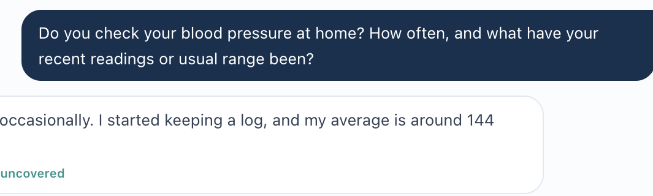
AI-patient evidence: Maria reports a home BP average around 144/90 mmHg.
AI-grader evidence: the grader expects approximately 146/91 mmHg and deducts for 144/90 mmHg.
Requested live EMR filename: MG_Tue_EMR_Home_BP_Average_01.png
Capture: Smallest readable live VACS section showing “Documented home BP log: Submitted; average ~144/90 mmHg.”

MG-TUE-02 — Grader forces moderate-intensity statin despite supported high-intensity therapy
Priority / status: High — Clinical reference conflict; live risk-profile capture pending.
Problem: The grader deducted points because the plan selected atorvastatin 40 mg (high-intensity) instead of atorvastatin 20 mg (moderate-intensity).
What the student saw or heard: The current case identifies a 54-year-old patient with type 2 diabetes plus additional cardiovascular risk factors including hypertension, dyslipidemia, and obesity. LDL-C is 112 mg/dL and no statin is currently prescribed.
What the supplied reference or grader expected: The grader specifically requests moderate-intensity atorvastatin 20 mg and deducts for atorvastatin 40 mg.
Why this is a problem: This is treatment-changing. The original Tuesday audit found that current ADA 2026 guidance supports high-intensity statin therapy for adults age 40-75 with diabetes who have additional ASCVD risk factors. A fixed requirement for atorvastatin 20 mg can therefore penalize a guideline-supported plan.
Suggested fix: Do not hard-code atorvastatin 20 mg as the only acceptable answer. The rubric/grader should accept guideline-supported high-intensity statin therapy when the documented case includes additional ASCVD risk factors, or the case/rubric should be changed consistently if moderate intensity is the intended educational target.

Focused screenshot evidence
AI-grader evidence: deductions require moderate-intensity atorvastatin 20 mg rather than atorvastatin 40 mg.
Requested live EMR filename: MG_Tue_EMR_Statin_Risk_Factors_01.png
Capture: Smallest readable live VACS area showing Maria’s age/diabetes, the relevant additional cardiovascular risk factors, and that no statin is currently prescribed.
Verified clinical context: ADA 2026 recommendation 10.20 supports high-intensity statin therapy for diabetes at age 40–75 with additional ASCVD risk factors; atorvastatin 40 mg is a high-intensity dose. This supports accepting the documented risk-based plan rather than a single fixed moderate-intensity answer. [1]

MG-TUE-03 — Grader requires “mild fatigue” although the AI patient never says “mild”
Priority / status: Medium — Interview/grader conflict.
Problem: The grader deducted points because the SOAP used “intermittent fatigue” instead of the rubric wording “mild fatigue.”
What the student saw or heard: The AI patient says she gets “tired sometimes.” In another response, she says she is “tired a lot.” She does not characterize the fatigue as mild.
What the supplied reference or grader expected: The grader says the rubric specifies “mild fatigue” and removes points when the student preserves the patient’s actual wording instead.
Why this is a problem: The student should not have to invent symptom severity that the AI patient did not provide. Requiring the word “mild” creates a mismatch between the subjective interview source and the grader reference.
Suggested fix: Synchronize the AI patient and grading reference. Either have the patient clearly describe fatigue as mild, or allow accurate documentation such as “tired sometimes,” “fatigue,” or equivalent wording supported by the interview.

Focused screenshot evidence
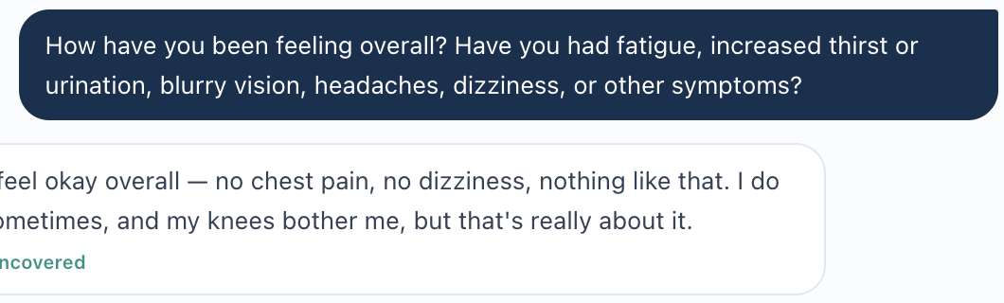
AI-patient evidence: Maria reports being tired sometimes; no “mild” severity is stated.
AI-grader evidence: the deduction requires the specific descriptor “mild fatigue.”

MG — Maria Gonzalez

Wednesday — 3-Month Ambulatory Care Follow-Up
AI-grader result: 82.4% (original recorded score).
Three reported issues: conflicting encounter-stage labels and deductions for satisfaction and improved BP-monitoring frequency that the recorded patient answer does not establish. The supplied checklist does not explicitly require the latter two subjective statements. Injectable preference was not elicited and remains an interview gap.
ID | Issue | Priority | Evidence / status
MG-WED-01 | Same Wednesday encounter is labeled as both 3-month follow-up and initial visit | High | Export-documented label conflict; live verification needed
MG-WED-02 | Grader requires clear satisfaction even though the AI patient expresses uncertainty | Medium | Interview/grader conflict
MG-WED-03 | Grader expects improved home-BP monitoring frequency that the case does not provide | Medium | Interview/grader conflict; live log capture pending

MG-WED-01 — Same Wednesday encounter is labeled as both 3-month follow-up and initial visit
Priority / status: High — Export-documented label conflict; live verification needed.
Problem: The live Wednesday case identifies the encounter as a 3-month ambulatory care follow-up, but another section of the same record labels it as an “Initial Ambulatory Care Pharmacist Visit.”
What the student saw or heard: At the top of the Wednesday record: “Wednesday · 3-Month Ambulatory Care Follow-Up.” Later in the same record: “Documented by: Intake RN · 06/23/2026 08:50 · Initial Ambulatory Care Pharmacist Visit.”
What the supplied reference or grader expected: The supplied Wednesday grading checklist and case content are structured as a 3-month follow-up, not a new initial visit.
Why this is a problem: Visit stage changes the clinical context. A student should not have to decide which of two conflicting stage labels is authoritative. If other workflow components use the incorrect “initial visit” label, the wrong treatment stage can affect prompts, grading, or case interpretation.
Suggested fix: Make every Wednesday component use the same visit stage. For this case, the intake documentation should identify the encounter as the Wednesday 3-month ambulatory care follow-up, or the full case should be changed consistently if a different stage is intended.

Focused screenshot evidence
Live EMR screenshot evidence is still needed. The current text export contains both labels, but an exported document is not accepted as live-screen proof.
Requested live EMR filename: 1: MG_Wed_EMR_Visit_Stage_01.png
Capture: Smallest readable live VACS area showing “Wednesday · 3-Month Ambulatory Care Follow-Up.”
Requested live EMR filename: 2: MG_Wed_EMR_Visit_Stage_02.png
Capture: Smallest readable live VACS area showing the intake documentation line containing “Initial Ambulatory Care Pharmacist Visit,” with enough surrounding context to establish that it is the same Wednesday encounter.

MG-WED-02 — Grader requires clear satisfaction even though the AI patient expresses uncertainty
Priority / status: Medium — Interview/grader conflict.
Problem: The grader removed points because the SOAP preserved the patient’s uncertainty about her progress instead of documenting “clear satisfaction with progress.”
What the student saw or heard: When directly asked how she feels about the progress she has made, Maria says she feels she is making progress but is not sure it is enough yet. She adds that her walking, diet, sugars, and blood pressure have improved but that she still has work to do, especially with weight.
What the supplied reference or grader expected: The AI grader deducts 0.4 points because the patient “expresses uncertainty” rather than “clear satisfaction with progress.” The supplied grading checklist does not identify clear satisfaction as a required Wednesday element.
Why this is a problem: This is a subjective-history integrity problem. The student accurately documented the patient’s actual attitude. Requiring a more positive response would force the student to replace the patient’s words with unsupported information.
Suggested fix: Make the grader accept accurate documentation of the current AI-patient response. If clear satisfaction is required for the case, change the AI patient so she actually expresses that satisfaction before grading students against it.

Focused screenshot evidence
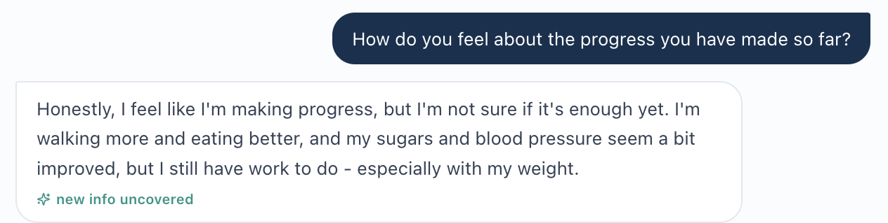
AI-patient evidence: Maria says she is making progress but is not sure it is enough yet.
AI-grader evidence: 0.4-point deduction requires “clear satisfaction with progress.”

MG-WED-03 — Grader expects improved home-BP monitoring frequency that the case does not provide
Priority / status: Medium — Interview/grader conflict; live log capture pending.
Problem: The grader deducts points because the SOAP does not state that home-BP monitoring consistency or frequency improved. The AI patient was directly asked how often she checks BP but did not provide a frequency; she gave only the current BP range/average and stated that she writes readings down.
What the student saw or heard: The AI patient is asked, “Do you check your blood pressure at home? How often...?” She answers that readings are around 134/82, systolic values are generally in the high 120s to 140, and she writes them down. She does not state how many times per week she checks. The Wednesday EMR text similarly documents a submitted home BP average of 134/82 and appropriate technique, but no monitoring frequency.
What the supplied reference or grader expected: The AI grader deducts 0.4 points because improved home-BP monitoring “consistency/frequency” was not explicitly stated. The supplied Wednesday grading checklist does not list improved BP-monitoring frequency among its core expected items.
Why this is a problem: The student cannot document an exact improvement in frequency when neither the AI patient nor the visible case provides that fact. Penalizing the omission creates pressure to invent subjective information.
Suggested fix: Either have the AI patient explicitly state the change in BP-monitoring frequency, display that frequency in the live case, or remove/relax this grading requirement so accurate documentation of the available answer receives credit.

Focused screenshot evidence
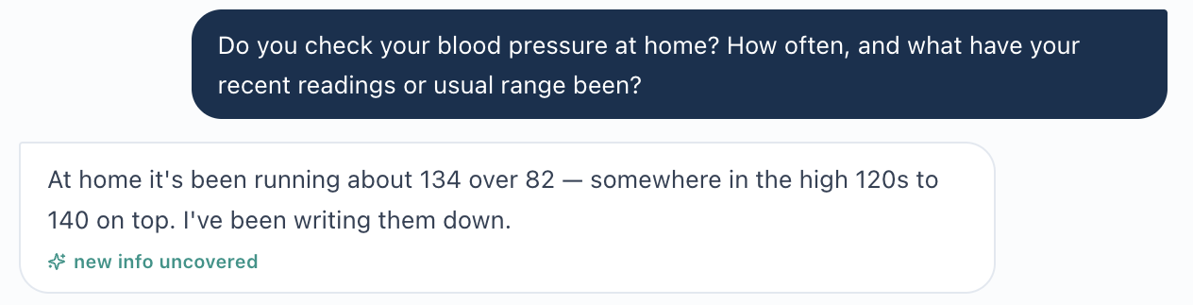
AI-patient evidence: the question asks for frequency, but the response provides readings and logging behavior without a frequency.
AI-grader evidence: 0.4-point deduction expects improved consistency/frequency of home BP monitoring.
Additional live EMR screenshot still needed if screenshot-level proof is required: MG_Wed_EMR_Home_BP_Log_01.png. Capture only the live “Home BP log” section showing the submitted average 134/82 and “technique appears appropriate.”

MG — Maria Gonzalez

Thursday — 6-Month Follow-Up
AI-grader result: 87.2% (original recorded score).
One reported issue: follow-up versus initial-visit labels within the same exported encounter. No additional Thursday grader/data mismatch was confirmed by the source audit. The remaining deductions concern SOAP precision and completeness.
ID | Issue | Priority | Evidence / status
MG-THU-01 | Same Thursday encounter is labeled as both 6-month follow-up and initial visit | High | Export-documented label conflict; live verification needed

MG-THU-01 — Same Thursday encounter is labeled as both 6-month follow-up and initial visit
Priority / status: High — Export-documented label conflict; live verification needed.
Problem: The current Thursday record identifies the encounter as a 6-month follow-up, but another section of the same record labels it as an “Initial Ambulatory Care Pharmacist Visit.” These two treatment-stage labels cannot both describe the same encounter.
What the student saw or heard: At the top of the Thursday record: “Thursday · 6-Month Follow-Up.” Later in the same record: “Documented by: Intake RN · 06/23/2026 08:50 · Initial Ambulatory Care Pharmacist Visit.” The surrounding Thursday content otherwise describes a 6-month return visit with longitudinal improvement.
What the supplied reference or grader expected: The supplied Thursday reference checklist and case reasoning are built around the 6-month follow-up stage: persistent albuminuria despite controlled BP, long-term kidney/CV protection, continued statin/ACE inhibitor therapy, preventive gaps, and sustainable monitoring. No reference material supplied for Thursday indicates that this is an initial visit.
Why this is a problem: Treatment stage determines the clinical context and what prior therapy or response the student should evaluate. Conflicting labels can confuse students, developers, and automated workflows, and may cause stage-specific prompts or grading logic to use the wrong encounter type. The student should never have to guess which stage label is authoritative.
Suggested fix: Make every Thursday component use one consistent visit stage. For this case, change the intake documentation so it identifies the encounter as the Thursday 6-month follow-up, unless the entire case is intentionally meant to be a different stage. Then verify that any stage-specific prompts, data, and grader references use the same value.

Focused screenshot evidence
Live EMR screenshot evidence is still needed. The uploaded EMR text contains both labels, but an exported/pasted document is tracking/context evidence rather than proof of what the current live VACS screen displays.
Requested live EMR filename: 1: MG_Thu_EMR_Visit_Stage_01.png
Capture: Show the smallest readable live VACS area containing “Thursday · 6-Month Follow-Up” and enough header context to identify Maria Gonzalez.
Requested live EMR filename: 2: MG_Thu_EMR_Visit_Stage_02.png
Capture: Show the smallest readable live VACS area from the same Thursday encounter containing “Documented by: Intake RN … Initial Ambulatory Care Pharmacist Visit,” with enough nearby context to establish that it is the same patient/encounter.

JW — James Wilson

Tuesday — Initial Ambulatory Care Visit
AI-grader result: 71% (original recorded score).
Two findings need developer investigation: unsupported patient-history expectations and contradictory affordability scoring. Two additional low-priority wording/referral concerns are retained separately as verification items. All four supplied reference-checklist priorities were supported; the checklist is not the complete weighted rubric.
ID | Issue | Priority | Evidence / status
JW-TUE-01 | Patient facts required without interview support | Medium | Needs targeted interview/grader investigation
JW-TUE-02 | Affordability priority is recognized and deducted | Medium | Observed feedback conflict; submitted payload retest needed
JW-TUE-V1 | Visit type and setting | Low | Provisional wording concern; unable to verify live
JW-TUE-V2 | Specific reason for referral | Low | Provisional referral concern; unable to verify live

JW-TUE-01 — Patient facts required without interview support
Priority / status: Medium — Needs targeted interview/grader investigation.
Problem: The grader deducts for specific emotions, beliefs, and goals that were not reported in the seven interview screenshots. Cost and a family history of stroke are documented. They do not establish embarrassment, an assumption that no alternative exists, a failure to notify clinicians, or a personal fear of stroke.
What the student heard: The patient says Jardiance cost over $500 per month and he never picked it up. He sometimes delays refills until his pension check arrives. He fears needing insulin, wants less fatigue, and wants better disease control.
What the AI grader expected: Frustration [1B.4], failure to notify the physician or pharmacy [1B.8], belief that no alternatives existed [1B.9], embarrassment or initial minimization [1B.12], retirement independence [1G.2], personal stroke concern [1G.3], and a link to his father’s stroke [1G.4]. It also expects established knowledge deficits [3A.14; 3G.1–3G.6].
Why this is a problem: Students may insert unverified patient history to recover points. An inability to pay is not proof that the patient believes a medicine is optional.
Suggested fix: Align expected patient history with what the AI patient provides. Where further questions are required, distinguish a failure to elicit information from a failure to document known facts. Do not require unsupported beliefs as established history.
Verification limit: Additional questions about embarrassment, reporting costs, alternatives, or medicine knowledge were not asked. These screenshots do not prove the AI patient could never disclose those facts. The finding concerns the unsupported expectations in this grading run; broader patient behavior needs targeted testing.

Focused screenshot evidence
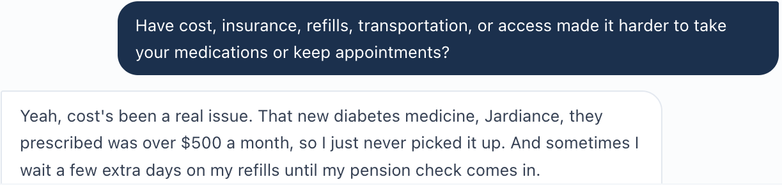
Interview 05: the complete visible cost answer identifies unaffordable treatment and delayed refills.
Feedback 03: [1B.4] removes 0.3 points for frustration that was not reported.
Feedback 03: [1B.8] and [1B.9] remove points for unverified reporting behavior and beliefs.
Feedback 03: [1B.12] removes 0.3 points for unverified embarrassment or minimization.

Additional evidence on goals and knowledge
The patient was asked about future complications and his main treatment goals. Both answers emphasize avoiding insulin. A family history of stroke does not establish the patient’s own stroke concern.
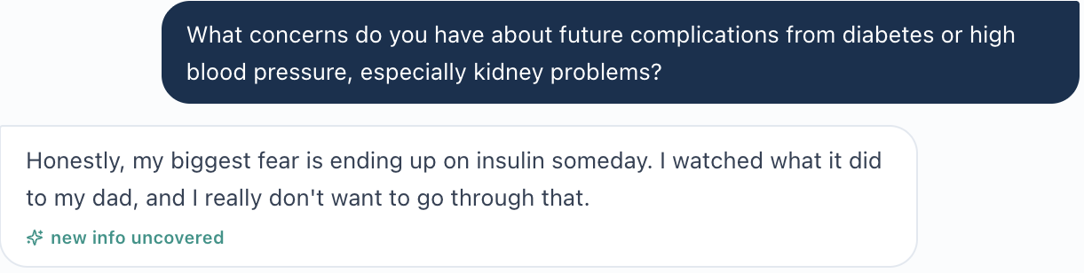
Interview 03: question about future complications and full answer about fear of needing insulin.
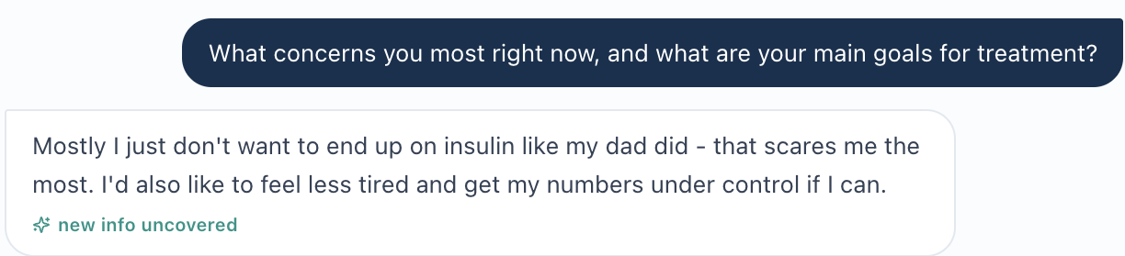
Interview 07: main goals are avoiding insulin, feeling less tired, and improving his numbers.
Feedback 03: [1G.2–1G.4] deduct for retirement independence, personal stroke fear, and a link to his father’s stroke.
The complete interview contains no direct test of A1C or medicine-purpose understanding. The strongest unsupported belief is [3G.5], which characterizes unaffordable treatment as a misconception that medicine is optional. General education or asking about understanding can be legitimate clinical tasks; those omissions are separate from assigning an unconfirmed belief to this patient.
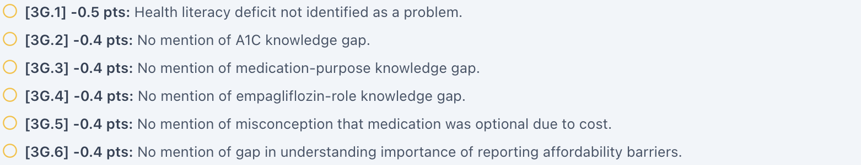
Feedback 05: [3G.1–3G.6] expect specific knowledge deficits and the optional-medicine misconception.
Feedback 04: [3A.14] also expects limited diabetes understanding as a contributor.
Retest passes when: The grader accepts supported patient goals and the documented cost barrier, and does not demand unreported beliefs as facts. If more history is required, neutral questions must be able to elicit it and feedback must identify the interviewing gap accurately.

JW-TUE-02 — Affordability priority is recognized and deducted
Priority / status: Medium — Observed feedback conflict; submitted payload retest needed.
Problem: Deduction [3D.2] removes 0.6 points for not identifying medication affordability as the most significant medication-related problem. The SOAP provided in this audit thread explicitly names affordability and access as the primary barrier. The grader’s Strengths section recognizes the same concept.
What the student documents: The diabetes Assessment states: “Primary current barrier is medication affordability/access rather than demonstrated failure of fully adherent therapy.” The separate medication-access assessment also identifies non-initiation due to cost and medication stretching.
What the AI grader expected: [3D.2] says the note does not state that medication access or affordability is the most significant medication-related problem. In Strengths, the grader says the Assessment appropriately identifies these barriers and the Plan prioritizes addressing them before intensifying treatment.
Why this is a problem: Equivalent clinical meaning receives contradictory feedback. Students cannot tell whether the affordability priority earned credit.
Suggested fix: Make [3D.2] award credit when the Assessment explicitly identifies affordability or access as the primary barrier. Check that the point decision and narrative feedback agree on the same submitted note.

Focused screenshot evidence
Feedback 05: exact [3D.2] deduction and visible 0.6-point loss.
Feedback 01: the grader recognizes affordability and adherence as key barriers and the Plan’s priority.
SOAP source: the Assessment block supplied immediately before grading in the audit conversation. This quotation is text evidence; it is not a live VACS field screenshot. The original submitted SOAP payload was not independently exported, so a controlled retest should confirm the same wording reaches the grader.

Targeted verification
Grade the same supported Assessment wording again. A passing result credits [3D.2] and keeps the narrative consistent. Preserve the submitted SOAP field or payload and the full returned feedback. This issue needs a grader retest; it does not require another patient interview or EMR screenshot.

JW-TUE-V1 — Visit type and setting
Priority / status: Low — Provisional wording concern; unable to verify live.
Student-facing text in the export: “Tuesday · Initial Ambulatory Care Visit” and “Ambulatory care clinic.” The intake documentation also says “Initial Ambulatory Care Pharmacist Visit.” A pharmacist of record is identified.
Grader expectation: [1A.3] requires “collaborative practice management”; [1A.4] requires a pharmacy clinic setting. The displayed wording may describe the same visit, so a wording preference alone does not prove a system defect.
Why this matters and requested action: Verify the live labels. Accept equivalent supported visit descriptions, or display the required formal visit type and setting in the student-facing encounter.
Feedback 03: visit-type and setting deductions total 0.3 raw points.
Additional live EMR filename: JW_Tue_EMR_Visit_Type_Setting_01.png
Capture: Show James Wilson, the Tuesday visit label, clinic setting, and the intake visit title or pharmacist line if they fit at a readable size.

JW-TUE-V2 — Specific reason for referral
Priority / status: Low — Provisional referral concern; unable to verify live.
Student-facing text in the export: “Referred by PCP for diabetes and blood pressure management.” The patient says his doctor sent him to improve diabetes and BP control. Elevated BP and a rising A1C are available findings.
Grader expectation: [1A.8] and [1A.9] require persistent BP elevation and worsening blood sugar control to be named as the referral triggers. Those findings support clinical interpretation but do not independently prove the referring clinician’s exact stated reason.
Why this matters and requested action: Confirm whether the live referral records these triggers. If required as historical facts, display them there; otherwise allow the documented general referral reason and supported clinical interpretation.
Feedback 03: referral-trigger deductions total 0.6 raw points.
Additional live EMR filename: JW_Tue_EMR_Referral_HPI_01.png
Capture: Show the live Chief Concern and HPI with the patient’s opening statement and the documented referral reason. Include only enough patient and visit context to identify the encounter.

JW — James Wilson

Wednesday — 3-Month Follow-Up
AI-grader result: 89.4% (original recorded score).
One observed grading issue concerns lipid monitoring after a dose change. Two chart concerns remain provisional: stale problem-summary values and an initial-visit title within the follow-up export. The SOAP recognized improvement, sustainable affordability, and avoidance of automatic escalation.
ID | Issue | Priority | Evidence / status
JW-WED-01 | Grader rejects correct monitoring after a dose change | Medium | Observed clinical-reference deduction; retest needed
JW-WED-02 | Current problem summaries may retain old values | Medium | Provisional stale-value concern; unable to verify live
JW-WED-03 | Initial visit title may remain in the follow up | Low | Provisional encounter-label concern; unable to verify live

JW-WED-01 — Grader rejects correct monitoring after a dose change
Priority / status: Medium — Observed clinical-reference deduction; retest needed.
Problem: Deduction [4C.3] removes 0.3 raw points because the plan repeats lipids 4–12 weeks after a dose change instead of 6–12 months. These intervals apply to different treatment situations.
What the student documents: The SOAP plan recommends repeat lipids 4–12 weeks after any atorvastatin dose change. It continues the existing dose pending review and discusses a possible higher dose. The short monitoring interval is conditional on a treatment change.
What the AI grader expected: The feedback says: “Lipid panel repeat is timed at 4–12 weeks after dose change rather than the expected 6–12 month interval.”
Why this is a problem: The deduction labels an appropriate post-change check as incorrect. Following the grader literally could delay checking the response to a medicine change.
Suggested fix: Make the lipid-monitoring criterion distinguish treatment changes from stable treatment. Accept 4–12 weeks after initiation or a dose change. Assess routine stable-treatment monitoring separately; the SOAP could add that interval without replacing the appropriate post-change check.

Focused screenshot evidence
Feedback 04: the complete [4C.3] deduction and 0.3-point loss, shown as two original-image crops in reading order. The word “change” overlaps for continuity. No feedback text has been rewritten.
Clinical reference: ADA Standards of Care in Diabetes 2026, recommendation 10.17: obtain a lipid profile when therapy starts, 4–12 weeks after initiation or a dose change, and annually thereafter.
ADA 2026 Cardiovascular Disease and Risk Management — recommendation 10.17
Evidence limit: The SOAP wording is taken from the note supplied in the audit conversation. The exact submitted VACS SOAP field or grading payload was not independently exported. The feedback itself explicitly identifies the post-dose-change interval.
Verification: Retest the same conditional interval. It should receive appropriate credit. Preserve the submitted SOAP wording and full returned feedback. No new patient interview or live EMR screenshot is needed for this timing issue.
Verified clinical context: ADA 2026 recommendation 10.17 distinguishes checking lipids 4–12 weeks after starting or changing therapy from annual monitoring on ongoing therapy. Credit the conditional post-change interval and evaluate any missing stable-treatment interval separately. [1]

JW-WED-02 — Current problem summaries may retain old values
Priority / status: Medium — Provisional stale-value concern; unable to verify live.
What the export shows: The active problems and problem list retain Tuesday values while Wednesday vitals and laboratory panels show improvement.
Measure | Problem summary | Wednesday current panel
A1C | 8.8% | 7.9%
BP | 152/94 mmHg | 138/86; repeat 136/84 mmHg
LDL | 103 mg/dL | 84 mg/dL
BMI | 31.9 | 31.1
Grader or reference expectation: The feedback recognizes improved current values. No conflicting objective-value deduction was identified.
Why this is a problem: An unlabeled old summary could make disease control appear worse and obscure the response to treatment.
Please verify and fix if reproduced: Check the live Wednesday summaries against the current panels. If these are current summaries, update their values. If historical, label them clearly as prior-visit values.
Live evidence needed: JW_Wed_EMR_Problem_Summary_Conflict_01.png
Capture: Show the Wednesday patient heading, the old summary values, and the current panels where possible. Use _02.png if separate screens are needed at readable zoom.

JW-WED-03 — Initial visit title may remain in the follow up
Priority / status: Low — Provisional encounter-label concern; unable to verify live.
What the export shows: The header says “Wednesday · 3-Month Follow-Up.” Intake documentation says “Initial Ambulatory Care Pharmacist Visit.” The setting says “Ambulatory care clinic.”
Grader expectation: The grader evaluates a follow-up and deducts 0.2 points at [1A.4] for not naming an ambulatory care pharmacy clinic. Equivalent clinic wording alone is not a confirmed system defect.
Why this matters and requested action: Verify whether the intake title describes the current encounter or a historical note. Correct a stale current title or make historical context explicit. Confirm that accepted clinic wording matches the student-facing setting.
Live evidence needed: JW_Wed_EMR_Visit_Stage_Label_01.png
Capture: Show the Wednesday follow-up header, clinic setting, and initial-visit intake title with enough context to distinguish current from historical documentation.

JW — James Wilson

Thursday — 6-Month Follow-Up / Second Follow-Up
AI-grader result: 87.9% (original recorded score).
Three reported grading/reference conflicts involve BP-monitoring frequency, sodium, and pneumococcal vaccine eligibility. Three additional chart concerns require live verification: stale summaries, visit-stage wording, and BSA calculation. The SOAP addressed BP at goal, lifestyle reinforcement, and long-term affordability.
ID | Issue | Priority | Evidence / status
JW-THU-01 | Grader requires a different home BP checking frequency | Medium | Interview/grader conflict
JW-THU-02 | Sodium differs between the export and grader | Medium | Export/grader conflict; live sodium proof needed
JW-THU-03 | Grader uses an outdated pneumococcal age criterion | High | Observed clinical-reference deduction; retest needed
JW-THU-04 | Current problem summaries may retain baseline values | Medium | Provisional stale-value concern; unable to verify live
JW-THU-05 | Initial visit title may remain in the follow up | Low | Provisional encounter-label concern; unable to verify live
JW-THU-06 | Body surface area may not match displayed inputs | Low | Provisional calculation concern; unable to verify live

JW-THU-01 — Grader requires a different home BP checking frequency
Priority / status: Medium — Interview/grader conflict.
Problem: Deduction [1B.8] removes 0.3 raw points because the SOAP says BP is checked 1–2 times weekly. The grader expects “several times weekly,” which differs from the recorded patient answer.
What the student heard: When asked how often he checks BP, the patient says “about 1 to 2 times a week.” He reports readings in the 120s/70s and an average of about 126/78.
What the student documents: The Subjective section accurately records: “BP checked 1–2 times weekly, usually 120s/70s, averaging approximately 126/78.”
What the AI grader expected: [1B.8]: “States BP checked 1–2 times weekly, not ‘several times weekly’ as expected.”
Why this is a problem: The student loses credit for accurately documenting the patient’s answer. Replacing the answer with the expected frequency would create false subjective history.
Suggested fix: Align the Thursday patient answer and grader expectation. Award credit for the frequency actually reported. If the intended case requires a different frequency, change the patient case data and verify the answer before changing the reference.

Focused screenshot evidence

Interview 03: the visible BP question and complete answer establish 1–2 checks weekly.
Feedback 03: exact [1B.8] deduction and 0.3-point loss.

Targeted verification

JW-THU-02 — Sodium differs between the export and grader
Priority / status: Medium — Export/grader conflict; live sodium proof needed.
Problem and student-facing value: The Thursday EMR export lists Na 138 mEq/L in the metabolic panel and All Labs. The SOAP records 138 mEq/L.
Grader expectation: [2B.5] removes 0.3 raw points because the grader expects 139 mEq/L.
Why this is a problem: A small numerical difference still makes accurate chart transcription lose credit. The student should use the displayed result.
Suggested fix: Verify the live Thursday sodium. Make the grader use the same result; correct the chart instead only if the intended case result is confirmed to be different.

Focused screenshot evidence
Feedback 03: [2B.5] explicitly contrasts documented 138 with expected 139.
Evidence limit: No live lab screenshot is available. The EMR Word export supplies text context and is not used as live-system screenshot proof.
Live evidence needed: JW_Thur_EMR_Sodium_Conflict_01.png
Capture: Show James Wilson’s Thursday visit context and the live sodium result, including Na 138 mEq/L if still displayed.

JW-THU-03 — Grader uses an outdated pneumococcal age criterion
Priority / status: High — Observed clinical-reference deduction; retest needed.
Problem and student plan: The patient is 62. The SOAP checks vaccination history and offers PCV20 or PCV21 if history remains unknown. Deduction [3H.3] removes 0.1 raw points for not stating an age ≥65 criterion.
Current recommendation: CDC recommends routine pneumococcal conjugate vaccination from age 50 for adults who have never received a conjugate vaccine or whose history is unknown. The ≥65 criterion in this deduction is not the current routine starting age.
Why this is a problem: An outdated age threshold could incorrectly suggest waiting to provide indicated preventive care.
Suggested fix: Update the Thursday criterion to current age- and vaccination-history-based guidance. Accept an explicit age ≥50 rationale when applicable. The SOAP could state that rationale more clearly, but should not be required to state an outdated threshold.

Focused screenshot evidence
Feedback 05: exact [3H.3] deduction requires the age ≥65 criterion.
CDC Pneumococcal Vaccine Recommendations — Adults 50 years or older
CDC guidance checked October 1 2026. No additional live EMR image is needed to establish the reference error. Retest with current eligibility reasoning and preserve the returned feedback.
Verified clinical context: CDC routine pneumococcal conjugate vaccination begins at age 50 for adults without prior PCV or with unknown history. Prior vaccine history determines the appropriate schedule. A blanket age-65 requirement is outdated for this 62-year-old patient. [2]

JW-THU-04 — Current problem summaries may retain baseline values
Priority / status: Medium — Provisional stale-value concern; unable to verify live.
Problem and evidence available: Active problems and the problem list retain old values while current Thursday panels show improvement:
Measure | Problem summary | Current Thursday panel
A1C | 8.8% | 7.1%
BP | 152/94 mmHg | 128/80; repeat 126/78 mmHg
LDL | 103 mg/dL | 72 mg/dL
BMI | 31.9 | 30.2
Why this matters and please fix: Old values presented as current can obscure treatment response. Verify the live fields; update current summaries or label historical values clearly. No conflicting grader deduction for these four values was identified.
Live evidence needed: JW_Thur_EMR_Problem_Summary_Conflict_01.png
Capture: Show the Thursday heading, old problem-summary values, and updated panels where readable. Use _02.png if separate screens are necessary.

JW-THU-05 — Initial visit title may remain in the follow up
Priority / status: Low — Provisional encounter-label concern; unable to verify live.
Problem and evidence available: The export header says “Thursday · 6-Month Follow-Up,” but intake documentation says “Initial Ambulatory Care Pharmacist Visit.” No wrong-stage grader deduction was identified.
Why this matters and please fix: A stale current title could confuse the encounter stage. Verify whether this is current or historical documentation. Correct a current title or identify historical context explicitly.
Live evidence needed: JW_Thur_EMR_Visit_Stage_Label_01.png
Capture: Show both visit labels and enough surrounding context to distinguish a current intake entry from a historical note.

JW-THU-06 — Body surface area may not match displayed inputs
Priority / status: Low — Provisional calculation concern; unable to verify live.
Problem and evidence available: The export shows height 5′10″, weight 95.5 kg, and “BSA (Mosteller)” 2.04 m². The Mosteller formula using 177.8 centimeters and 95.5 kg gives approximately 2.17 m².
Why this matters and please fix: This derived value does not match the displayed inputs. No current medicine in this case is dosed by BSA. Verify the live inputs and recalculate the labeled result if reproduced.
Live evidence needed: JW_Thur_EMR_BSA_Calculation_01.png
Capture: Show height 5′10″, weight 95.5 kg, and BSA (Mosteller) 2.04 m² together.

LM — Linda Martinez

Tuesday — Initial Ambulatory Care Visit
AI-grader result: 77.4% (original recorded score).
Six reported findings: conflicting allergy states, established cardiovascular history labeled missing, a kidney-assessment prompt inconsistent with worsening UACR, smoking-history mismatch, hidden glucose-monitoring frequency, and visit terminology. EMR-only findings are supported by exports and still need live-screen confirmation.
ID | Issue | Priority | Evidence / status
LM-TUE-01 | Penicillin allergy conflicts with “NKDA - no conflicts” | High | Export-documented allergy conflict; live verification needed
LM-TUE-02 | Known cardiovascular history is marked “Missing” | Medium | Export-documented missing-data flag; live verification needed
LM-TUE-03 | Kidney assessment prompt conflicts with worsening UACR and initial visit | High | Export-documented scaffold conflict; live verification needed
LM-TUE-04 | Grader expects “never smoker” despite patient reporting former smoking | Medium | Interview/grader conflict
LM-TUE-05 | Grader requires a glucose-check frequency the patient did not provide | Medium | Interview/grader conflict
LM-TUE-06 | Grader requires visit terminology not shown in the encounter | Medium | Export/grader terminology concern; live verification needed

LM-TUE-01 — Penicillin allergy conflicts with “NKDA - no conflicts”
Priority / status: High — Export-documented allergy conflict; live verification needed.
Problem:
The encounter contains two incompatible allergy states. The detailed allergy information lists penicillin with rash and hives, while the medication screen reports “NKDA - no conflicts.”
What the student saw or heard:
The patient reports a childhood penicillin reaction with rash and hives. The uploaded EMR copy also lists penicillin as a severe allergy, but the medication area shows “NKDA - no conflicts.”
What the supplied reference or grader expected:
Not applicable. This is an internal EMR contradiction rather than a SOAP-writing problem.
Why this is a problem:
An allergy checker that treats the patient as having no known drug allergies could miss a clinically important medication warning.
Suggested fix:
Make the medication allergy/interaction checker use the same penicillin allergy recorded in the detailed allergy section. Remove the “NKDA” state when a documented drug allergy exists.

Focused screenshot evidence
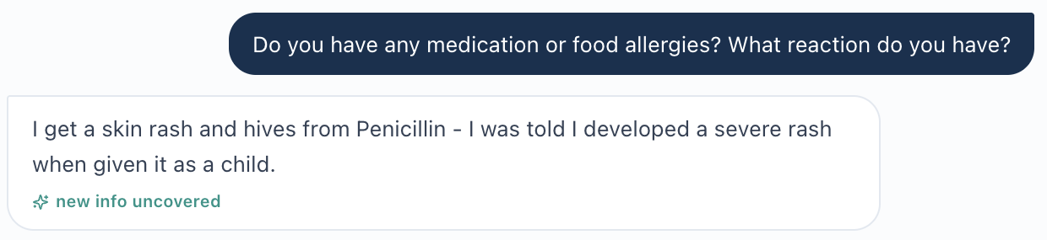
AI patient confirms penicillin caused rash and hives in childhood.
Evidence limitation: A live-browser screenshot of the detailed allergy field and the “NKDA - no conflicts” line was not supplied. Add the requested live EMR screenshots to fully prove the internal screen-to-screen contradiction.

LM-TUE-02 — Known cardiovascular history is marked “Missing”
Priority / status: Medium — Export-documented missing-data flag; live verification needed.
Problem:
The EMR context contains established cardiovascular history but also displays an “Additional / missing objective data” message for the same history: STEMI 3 years ago with PCI and DES placement.
What the student saw or heard:
The patient confirms a heart attack about 3 years ago with a coronary stent. Elsewhere in the EMR copy, secondary ASCVD prevention and prior STEMI are already listed.
What the supplied reference or grader expected:
Not applicable. The problem is that the live case appears to mark already-known history as missing.
Why this is a problem:
The “Missing” message can mislead the student into thinking required cardiovascular history is unavailable and can force unnecessary duplicate questioning.
Suggested fix:
Populate the cardiovascular-history field consistently and remove the “Missing” state when STEMI/PCI/DES history is already part of the encounter data.

Focused screenshot evidence
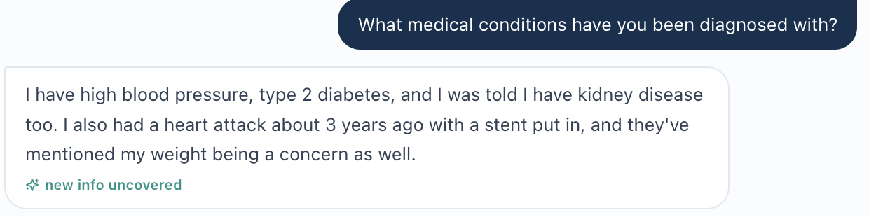
AI patient confirms prior heart attack with coronary stent about 3 years ago.
Evidence limitation: The live “Additional / missing objective data” screen was not supplied as a browser screenshot. The mismatch is documented from the uploaded EMR copy and should be confirmed against the live screen.

LM-TUE-03 — Kidney assessment prompt conflicts with worsening UACR and initial visit
Priority / status: High — Export-documented scaffold conflict; live verification needed.
Problem:
The kidney data show UACR worsening from 410 mg/g to 452 mg/g. However, the assessment scaffold asks, “How should you interpret the reduction in UACR?” and “What evidence suggests the original intervention worked?” The encounter is labeled an initial ambulatory care visit.
What the student saw or heard:
The student sees current UACR 452 mg/g with the explicit trend “Prior 410 mg/g → 452 mg/g (worsening).”
What the supplied reference or grader expected:
The assessment questions imply a later treatment stage with improved UACR and an intervention that has already been tested.
Why this is a problem:
This can push the student toward the opposite clinical interpretation of the visible data and may change treatment prioritization. It is also a visit-stage synchronization problem, not a static-calendar issue.
Suggested fix:
For the Tuesday initial visit, change the assessment scaffold to describe persistent/worsening albuminuria. If the “reduction/original intervention worked” questions belong to a follow-up case, move them to the correct encounter and synchronize the associated UACR data.

Focused screenshot evidence
Evidence limitation: No live-browser screenshot of the UACR trend or assessment scaffold was supplied. The contradiction is documented from the uploaded EMR copy and requires live-screen capture for final visual proof.

LM-TUE-04 — Grader expects “never smoker” despite patient reporting former smoking
Priority / status: Medium — Interview/grader conflict.
Problem:
The student accurately documented the patient as a former smoker. The grader deducted 0.4 points because its reference expects “never smoker.”
What the student saw or heard:
The AI patient states: “I’m a former smoker. I smoked about a pack a day for 20 years, but I quit 10 years ago.”
What the supplied reference or grader expected:
The grader states: “[1D.3] -0.4 pts: States ‘former smoker’ rather than ‘never smoker’ as specified by rubric.”
Why this is a problem:
The student is penalized for accurately documenting the patient’s direct answer. Changing the SOAP to “never smoker” would require inventing a fact that contradicts the interview.
Suggested fix:
Align the hidden smoking-history reference with the AI patient response, or change the AI-patient response if “never smoker” is truly intended. The grader should reward accurate documentation of the current patient answer.

Focused screenshot evidence
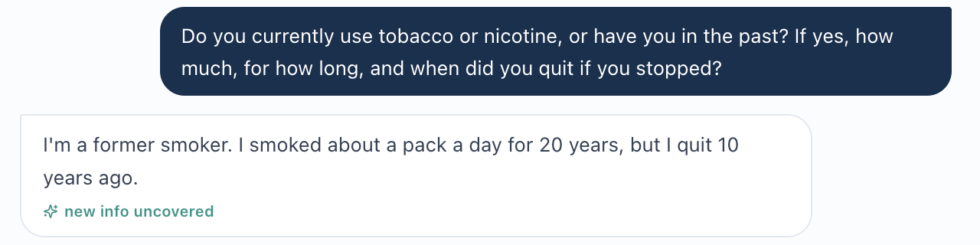
AI patient: former smoker, about 1 pack/day for 20 years, quit 10 years ago.
AI grader deducts points because it expects “never smoker.”

LM-TUE-05 — Grader requires a glucose-check frequency the patient did not provide
Priority / status: Medium — Interview/grader conflict.
Problem:
The patient gave a qualitative home glucose-monitoring frequency, but the grader requires a more specific frequency that was never stated.
What the student saw or heard:
When asked how often she checks blood sugar, the patient says, “Yes, I check it pretty regularly. My fasting numbers are usually around 150 to 180.” She does not say “several times weekly.”
What the supplied reference or grader expected:
The grader states: “[1B.6] -0.3 pts: States checks glucose ‘regularly’ rather than specifying several times weekly.”
Why this is a problem:
The student cannot safely convert “pretty regularly” into “several times weekly.” Doing so would invent subjective history to satisfy the grader.
Suggested fix:
Either have the AI patient provide the intended frequency when asked, or make the grader accept the exact frequency wording the patient actually provides. Do not require a frequency that is hidden from the student.

Focused screenshot evidence
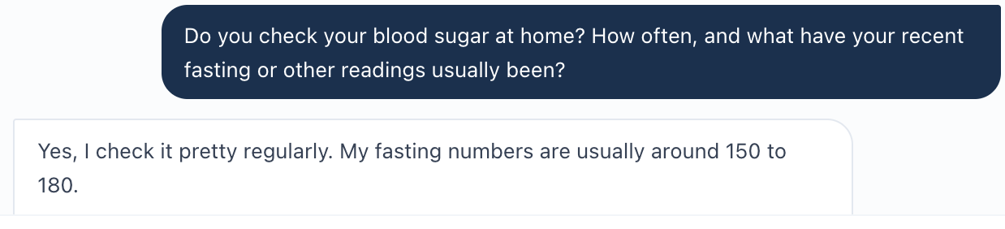
AI patient gives only “pretty regularly” for frequency and reports fasting readings around 150-180 mg/dL.
AI grader deducts because “several times weekly” was not documented.

LM-TUE-06 — Grader requires visit terminology not shown in the encounter
Priority / status: Medium — Export/grader terminology concern; live verification needed.
Problem:
The grader deducts points because the note does not call the visit a “collaborative practice management” encounter and does not name a more specific pharmacy-clinic setting.
What the student saw or heard:
The uploaded EMR copy labels the encounter “Tuesday · Initial Ambulatory Care Visit” and the location “Ambulatory care clinic.” Those are the visible labels available to the student.
What the supplied reference or grader expected:
The grader states that “initial ambulatory care visit” is insufficient without “collaborative practice management type” and that “ambulatory care visit” is insufficient without a specific pharmacy-clinic setting.
Why this is a problem:
The student is being graded on terminology that is not visible in the encounter. This encourages unsupported wording and makes grading depend on hidden labels rather than the live interface.
Suggested fix:
Either display the required visit type and pharmacy-clinic setting in the live encounter, or update the grader to accept the visible “Initial Ambulatory Care Visit” and “Ambulatory care clinic” labels.

Focused screenshot evidence
AI grader deductions for visit type and pharmacy-clinic setting.
Evidence limitation: A live-browser screenshot of the encounter header was not supplied. The visible labels are documented from the uploaded EMR copy and should be paired with a live header screenshot when available.

LM — Linda Martinez

Wednesday — First Follow-Up
AI-grader result: 77.5% (original recorded score).
Six reported findings. The allergy and stale-encounter problems persist, as do smoking and glucose-frequency mismatches. Additional findings concern subjective follow-up beliefs and required PCI/DES history not surfaced in the current encounter. The grader recognized albuminuria improvement, BP goal attainment, and residual risk.
ID | Issue | Priority | Evidence / status
LM-WED-01 | Penicillin allergy conflicts with “NKDA - no conflicts” | High | Export-documented allergy conflict; live verification needed
LM-WED-02 | Wednesday follow-up retains stale prior-visit values and initial-visit metadata | High | Export-documented stale values/metadata; live verification needed
LM-WED-03 | Grader expects “never smoker” despite direct former-smoker history | Medium | Interview/grader conflict, repeated from Tuesday
LM-WED-04 | Grader requires a glucose-monitoring frequency the patient did not provide | Medium | Interview/grader conflict, repeated from Tuesday
LM-WED-05 | Grader requires subjective follow-up beliefs and concerns not stated by the Wednesday patient | Medium | Current-interview/longitudinal-reference concern; targeted retest needed
LM-WED-06 | Grader requires STEMI/PCI/drug-eluting-stent detail not available in the Wednesday encounter | Medium | Current-encounter history gap; live/longitudinal verification needed

LM-WED-01 — Penicillin allergy conflicts with “NKDA - no conflicts”
Priority / status: High — Export-documented allergy conflict; live verification needed.
Problem:
The Wednesday encounter contains two incompatible allergy states. The detailed allergy record lists penicillin with rash and hives, while the medication area reports “NKDA - no conflicts.”
What the student saw or heard:
The AI patient again reports a childhood penicillin reaction with skin rash and hives. The Wednesday EMR copy also lists penicillin as a severe allergy.
What the supplied reference or grader expected:
Not applicable. This is an internal EMR contradiction rather than a SOAP-writing issue.
Why this is a problem:
An allergy checker that treats the patient as having no known drug allergies could fail to warn about a clinically important medication exposure.
Suggested fix:
Make the medication allergy/interaction checker use the same penicillin allergy recorded in the detailed allergy section. Remove the “NKDA” state whenever a documented drug allergy exists.

Focused screenshot evidence
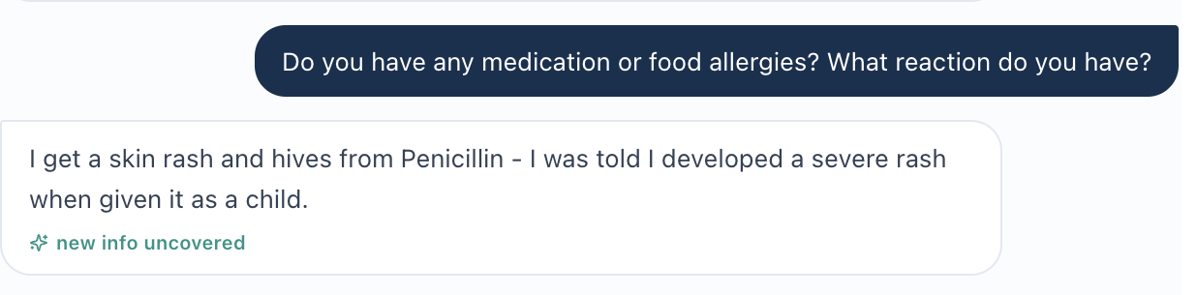
AI patient confirms penicillin caused rash and hives in childhood.
Evidence limitation: A live-browser screenshot showing both the “NKDA - no conflicts” line and the detailed penicillin allergy field was not supplied. Add that live EMR capture to provide final visual proof of the screen-to-screen contradiction.

LM-WED-02 — Wednesday follow-up retains stale prior-visit values and initial-visit metadata
Priority / status: High — Export-documented stale values/metadata; live verification needed.
Problem:
The current Wednesday encounter contains updated follow-up values, but the Problem List still displays prior values and the Subjective metadata still labels the encounter as an “Initial Ambulatory Care Pharmacist Visit.” This appears to be one stale-encounter synchronization problem affecting multiple fields.
What the student saw or heard:
Current Wednesday values include BP 130/78 with repeat 128/78, A1C 7.9%, eGFR 50, UACR 330 mg/g, LDL-C 86 mg/dL, and BMI 34.7. The same EMR copy later shows old Problem List values of BP 142/84, A1C 8.2%, eGFR 52/UACR 452, LDL 92, BMI 35.2. The header says “Wednesday · First Follow-Up,” while Subjective metadata says “Initial Ambulatory Care Pharmacist Visit.”
What the supplied reference or grader expected:
Not applicable. The current visit should present one synchronized set of follow-up values and one consistent visit stage.
Why this is a problem:
Stale values can mislead treatment decisions and grading. The visit-stage conflict can also cause the wrong reference data or workflow to be applied to a follow-up encounter.
Suggested fix:
Refresh the Wednesday Problem List from the current follow-up dataset and make all encounter metadata use the same follow-up stage. Do not carry forward Tuesday/initial values as if they are current.

Focused screenshot evidence
Evidence limitation: No live-browser screenshots of the current-value panels, stale Problem List, or “Initial Ambulatory Care Pharmacist Visit” metadata were supplied. The contradiction is documented from the uploaded Wednesday EMR copy and should be confirmed with the live screens.

LM-WED-03 — Grader expects “never smoker” despite direct former-smoker history
Priority / status: Medium — Interview/grader conflict, repeated from Tuesday.
Problem:
The student accurately documented the patient as a former smoker. The Wednesday grader again deducts points because its reference expects “never smoker.” This reproduces the Tuesday mismatch.
What the student saw or heard:
The AI patient states that she smoked about one pack per day for 20 years and quit 10 years ago.
What the supplied reference or grader expected:
The grader states: “[1D.3] -0.4 pts: Note documents patient as a former smoker rather than the expected never-smoker status.”
Why this is a problem:
The student is penalized for documenting the patient’s direct answer. Changing the SOAP to “never smoker” would require inventing a fact that contradicts the interview.
Suggested fix:
Align the hidden smoking-history reference with the AI-patient response, or change the AI-patient response if “never smoker” is truly intended. The grader should reward accurate documentation of the current patient answer.

Focused screenshot evidence
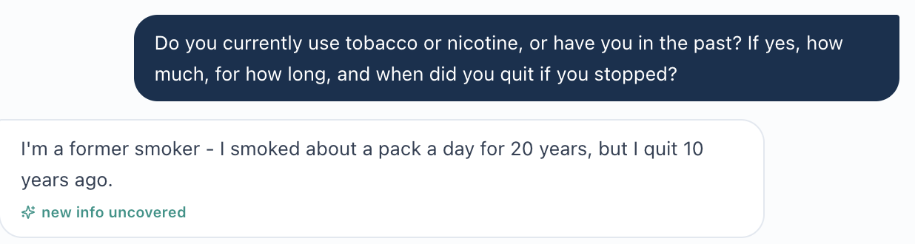
AI patient: former smoker, ~1 pack/day for 20 years; quit 10 years ago.
AI grader deducts points because it expects “never smoker.”

LM-WED-04 — Grader requires a glucose-monitoring frequency the patient did not provide
Priority / status: Medium — Interview/grader conflict, repeated from Tuesday.
Problem:
The Wednesday patient provides a qualitative glucose-monitoring frequency, but the grader requires a specific frequency that was never stated.
What the student saw or heard:
When asked how often she checks glucose, the patient says she checks it “regularly” and reports fasting readings of approximately 130–160 mg/dL. She does not say “several times weekly.”
What the supplied reference or grader expected:
The grader states: “[1B.9] -0.3 pts: Glucose monitoring frequency stated as ‘regularly’ rather than the specific ‘several times weekly.’”
Why this is a problem:
The student should not convert “regularly” into a more specific frequency. Doing so would invent subjective history to satisfy the grader.
Suggested fix:
Either have the AI patient provide the intended monitoring frequency when asked, or make the grader accept the exact frequency language the patient provides.

Focused screenshot evidence
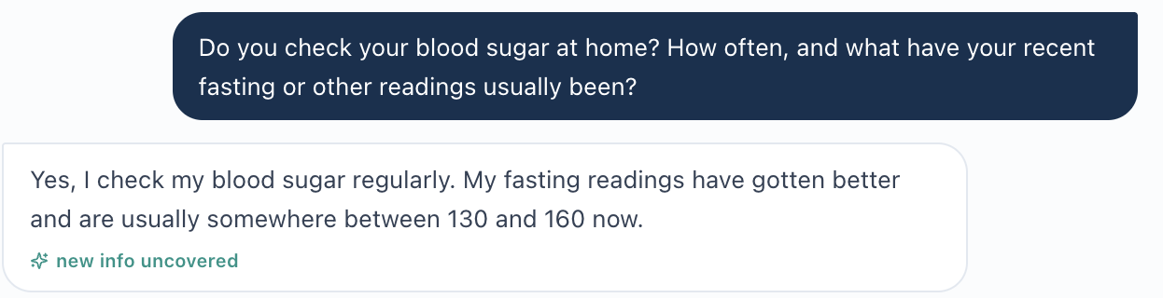
AI patient says she checks blood glucose “regularly” and gives fasting values, but no specific weekly frequency.
AI grader requires the hidden phrase “several times weekly.”

LM-WED-05 — Grader requires subjective follow-up beliefs and concerns not stated by the Wednesday patient
Priority / status: Medium — Current-interview/longitudinal-reference concern; targeted retest needed.
Problem:
The grader expects several subjective patient statements that the Wednesday AI patient does not actually provide: increased confidence managing chronic conditions, increased understanding of kidney disease, an explicit BP/diabetes/CKD/cardiovascular-risk relationship, fear of dialysis, and motivation to avoid another myocardial infarction.
What the student saw or heard:
The patient says she feels good about her progress, knows she remains high risk, is still most worried about her kidneys, and asks what should be prioritized next. She does not explicitly state fear of dialysis, a goal of avoiding another MI, or the detailed disease relationship the grader requires.
What the supplied reference or grader expected:
The grader deducts for missing increased confidence/understanding and the BP–diabetes–CKD–cardiovascular relationship, and separately deducts for no explicit dialysis concern and no explicit motivation to avoid another MI.
Why this is a problem:
These are subjective facts. Requiring them when the patient did not state them pushes the student to infer or import history from another encounter rather than document the current interview faithfully.
Suggested fix:
Make the Wednesday AI-patient responses include the intended subjective follow-up beliefs and concerns, or remove those requirements from the Wednesday grader. If longitudinal carry-forward is intended, surface that history to the student in the current workflow rather than keeping it hidden.

Focused screenshot evidence
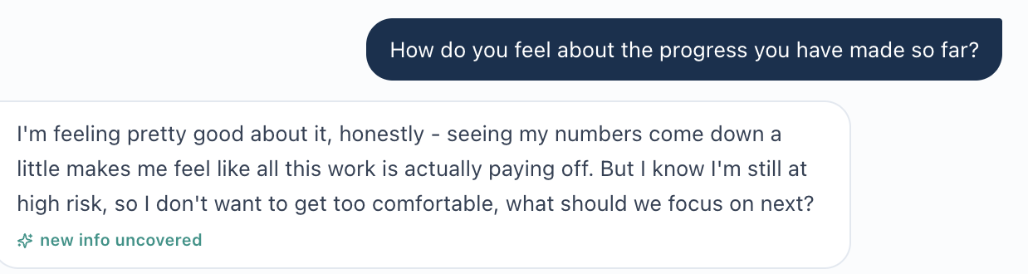
AI patient describes progress and motivation, but does not explicitly say she has increased confidence managing chronic conditions.
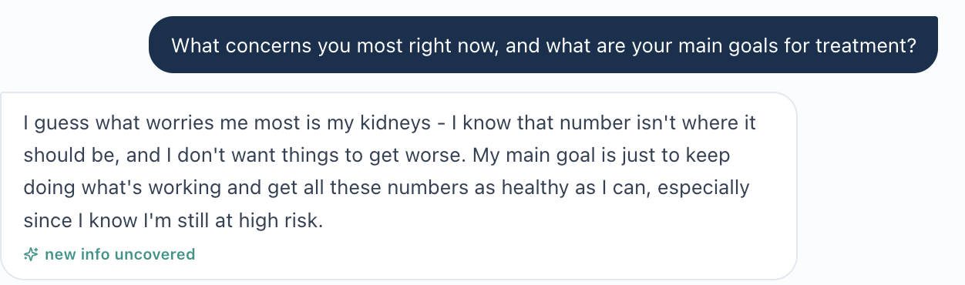
AI patient’s current stated concern is kidney worsening/high residual risk; dialysis and recurrent-MI goals are not stated.
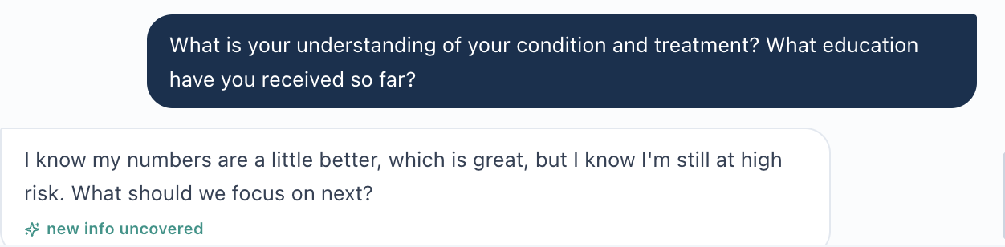
AI patient says she knows her numbers are better but remains high risk and asks what to focus on next.
AI grader expects increased confidence, increased understanding, and an explicit BP/diabetes/CKD/CV-risk relationship.
AI grader also expects explicit dialysis concern and motivation to avoid another MI.

LM-WED-06 — Grader requires STEMI/PCI/drug-eluting-stent detail not available in the Wednesday encounter
Priority / status: Medium — Current-encounter history gap; live/longitudinal verification needed.
Problem:
The Wednesday grader repeatedly requires detailed cardiovascular history including STEMI, PCI, timing, and a drug-eluting stent. The current Wednesday AI patient only says she had a heart attack a few years ago with a stent, and the Wednesday EMR copy surfaces prior STEMI but does not surface PCI or drug-eluting-stent detail.
What the student saw or heard:
The patient says she had a heart attack “a few years back with the stent.” The current Wednesday EMR identifies prior STEMI/secondary ASCVD prevention, but the supplied Wednesday encounter does not provide PCI/DES detail for the student to document.
What the supplied reference or grader expected:
The grader deducts for not specifying STEMI with PCI, not including timing/STEMI classification, and not documenting PCI with a drug-eluting stent in surgical history.
Why this is a problem:
The student should not be required to invent PCI/DES detail that is not visible in the current Wednesday EMR or provided by the current patient interview.
Suggested fix:
Surface the intended PCI/DES history in the Wednesday live encounter and/or have the AI patient provide it when asked. Otherwise, remove the unsupported PCI/DES requirements from the Wednesday grader.

Focused screenshot evidence
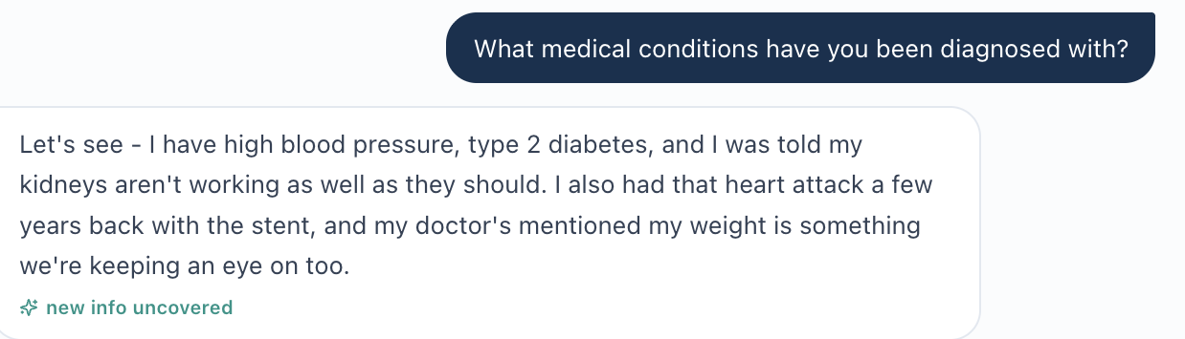
AI patient reports a prior heart attack with a stent, but does not provide PCI or drug-eluting-stent terminology.
Grader requires STEMI with PCI.
Grader requires timing and STEMI classification.
Grader requires PCI with a drug-eluting stent in surgical history.
Evidence limitation: A live-browser screenshot of the Wednesday Secondary ASCVD Prevention/history section was not supplied. The absence of PCI/DES wording is documented from the uploaded Wednesday EMR copy; add the live screen if visual proof is required.
Longitudinal verification note: Tuesday’s supplied LM export does include PCI/DES detail. This follow-up finding concerns whether that history is available in the current workflow; confirm whether students can access prior encounters before treating it as unavailable across the entire case.

LM — Linda Martinez

Thursday — Final Follow-Up
AI-grader result: 79.8% (original recorded score).
Six reported findings: allergy conflict, stale initial data/metadata, repeated smoking-history mismatch, scheduled-follow-up wording, unsupported motivations/vigilance statements, and hidden DES detail. The grader recognized cumulative improvement, a maintenance plan, and transition/ongoing monitoring. Export-derived images from the source report are omitted to follow the Week 3 evidence approach.
ID | Issue | Priority | Evidence / status
LM-THU-01 | Penicillin allergy conflicts with “NKDA - no conflicts” | High | Export-documented allergy conflict; live verification needed
LM-THU-02 | Final follow-up retains stale initial values and initial-visit metadata | High | Export-documented stale values/metadata; live verification needed
LM-THU-03 | Grader expects “never smoker” despite direct former-smoker history | Medium | Interview/grader conflict across all three visits
LM-THU-04 | Grader requires “scheduled follow-up” wording not supplied by the encounter | Medium | Export/grader terminology concern; live verification needed
LM-THU-05 | Grader requires subjective motivations and vigilance insight not stated by the patient | Medium | Current-interview/reference concern; targeted retest needed
LM-THU-06 | Grader requires drug-eluting stent detail not supplied in the Thursday encounter | Medium | Current-encounter DES-history gap; longitudinal verification needed

LM-THU-01 — Penicillin allergy conflicts with “NKDA - no conflicts”
Priority / status: High — Export-documented allergy conflict; live verification needed.
Problem: The Thursday encounter presents two incompatible allergy states. The medication section displays “NKDA - no conflicts,” while the detailed allergy record lists penicillin with rash and hives as a severe allergy.
What the student saw or heard: The AI patient again reports a childhood penicillin reaction with skin rash and hives. The Thursday EMR copy simultaneously shows NKDA in the medication checker and a severe penicillin allergy in the allergy table.
What the supplied reference or grader expected: Not applicable. This is an internal EMR contradiction rather than a SOAP-writing issue.
Why this is a problem: An allergy/interaction checker that treats the patient as having no known drug allergies could suppress clinically important warnings.
Suggested fix: Use one allergy source of truth. If penicillin allergy is documented, the medication/allergy checker must not display NKDA.
Evidence limitation: The contradiction is documented in the supplied EMR Word export. Export-derived images are omitted here; verify the same fields in the live application.
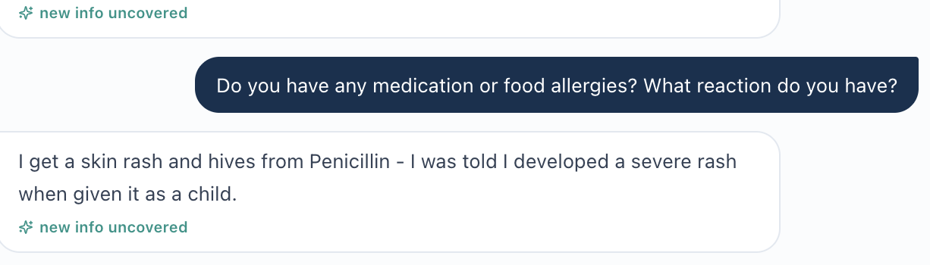
AI patient independently confirms childhood penicillin rash/hives.

LM-THU-02 — Final follow-up retains stale initial values and initial-visit metadata
Priority / status: High — Export-documented stale values/metadata; live verification needed.
Problem: The Thursday encounter contains current final-follow-up values, but the Problem List still shows the original initial-visit values and the Subjective metadata still calls the encounter an “Initial Ambulatory Care Pharmacist Visit.”
What the student saw or heard: Current Thursday data include UACR 210 mg/g (A2), LDL-C 63 mg/dL, A1C 7.2%, eGFR 49, BP 124/76 with repeat 122/74, and BMI 33.8. The Problem List still displays UACR 452/eGFR 52 (G3aA3), LDL 92, A1C 8.2%, BP 142/84, and BMI 35.2.
What the supplied reference or grader expected: Not applicable. One visit should present one synchronized set of current values and one consistent encounter stage.
Why this is a problem: The stale Problem List now misstates both severity and treatment response, including an A3 kidney classification after the current UACR has improved to A2. The initial-visit metadata also risks loading the wrong workflow or reference content.
Suggested fix: Refresh the Problem List from the Thursday dataset and make all encounter metadata use the Final Follow-Up stage. Historical values can remain as trends, but should not appear as the current problem-state summary.
Evidence limitation: The contradiction is documented in the supplied EMR Word export. Export-derived images are omitted here; verify the same fields in the live application.

LM-THU-03 — Grader expects “never smoker” despite direct former-smoker history
Priority / status: Medium — Interview/grader conflict across all three visits.
Problem: The student accurately documents the patient as a former smoker, but the grader deducts points because its hidden criterion requires “never smoker.”
What the student saw or heard: The Thursday AI patient states that she is a former smoker who smoked about one pack per day for 20 years and quit 10 years ago.
What the supplied reference or grader expected: The grader states that the documented 20-pack-year former-smoking history “does not match the required ‘never smoker’ status per rubric criteria.”
Why this is a problem: The student is penalized for accurately documenting a direct patient answer. Changing the SOAP to “never smoker” would require inventing a contradictory subjective fact. This same mismatch has reproduced in all three Linda Martinez encounters.
Suggested fix: Align the hidden smoking-history reference with the AI-patient response, or change the patient response if never-smoker status is truly intended. The grader should score the student against the actual encounter evidence.
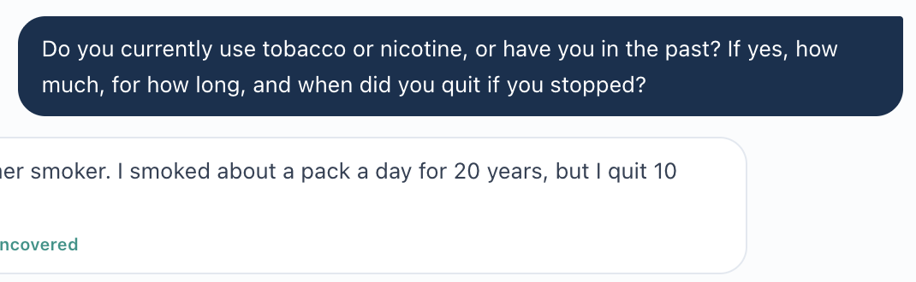
AI patient: former smoker, ~1 pack/day for 20 years; quit 10 years ago.
AI grader deducts points because it expects “never smoker.”

LM-THU-04 — Grader requires “scheduled follow-up” wording not supplied by the encounter
Priority / status: Medium — Export/grader terminology concern; live verification needed.
Problem: The student identifies the visit as the final ambulatory care follow-up, matching the visible encounter label. The grader still deducts points because the SOAP does not explicitly call it a “scheduled follow-up.”
What the student saw or heard: The encounter header says “Thursday · Final Follow-Up.” No student-facing Thursday field shown in the provided EMR copy labels the visit “scheduled follow-up.”
What the supplied reference or grader expected: The grader deducts 0.2 points because “final ambulatory care follow-up” does not explicitly state that the visit was scheduled.
Why this is a problem: A grader should not require a visit-type synonym that the student-facing case does not provide, especially when the student accurately transcribes the visible encounter type.
Suggested fix: Either expose “Scheduled Final Follow-Up” (or equivalent) in the encounter header, or accept “Final Follow-Up” as satisfying the visit-type criterion.
AI grader requires the additional phrase “scheduled follow-up.”

LM-THU-05 — Grader requires subjective motivations and vigilance insight not stated by the patient
Priority / status: Medium — Current-interview/reference concern; targeted retest needed.
Problem: The grader requires several patient-specific subjective statements that are not actually stated in the Thursday interview: motivation to avoid dialysis, prevent another MI, maintain independence, and explicit insight that improvement does not eliminate future risk.
What the student saw or heard: The patient clearly reports improved understanding and says treatment is intended to protect her heart and kidneys and control blood sugar and blood pressure. She does not explicitly state the four additional motivations/insight phrases required by the grader.
What the supplied reference or grader expected: The grader applies separate deductions for no dialysis-avoidance motivation, no recurrent-MI prevention motivation, no independence goal, and no explicit “continued vigilance despite improvement” insight.
Why this is a problem: These are subjective patient beliefs. A student should not infer or invent them. If the rubric requires those exact concepts, the AI patient must provide them when asked, or the grader must accept the patient's actual statements.
Suggested fix: Synchronize the AI-patient script and grading rubric. Either add those motivations/insight to the patient's responses or remove the requirement to document them as patient-reported subjective facts.
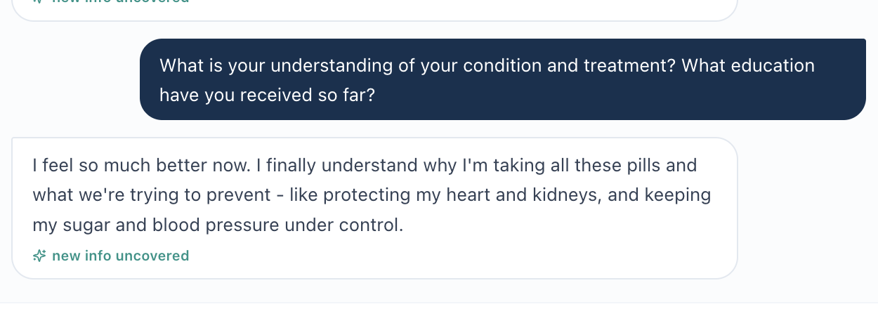
AI patient states improved understanding of heart/kidney protection and BP/glucose control, but not the hidden motivations listed by the grader.
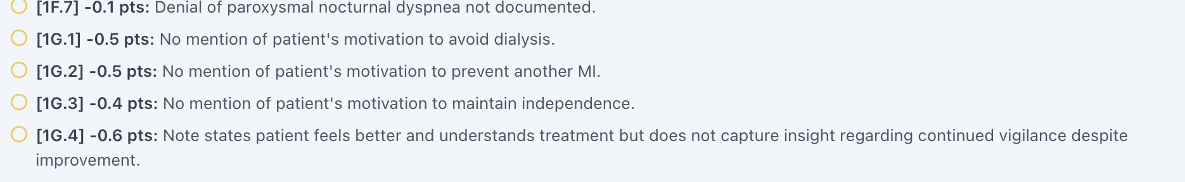
AI grader applies four separate deductions for unspoken motivation/vigilance content.

LM-THU-06 — Grader requires drug-eluting stent detail not supplied in the Thursday encounter
Priority / status: Medium — Current-encounter DES-history gap; longitudinal verification needed.
Problem: The Thursday grader expects the surgical history to identify the coronary stent as drug-eluting, but the Thursday patient only reports a heart attack with a stent and the current visible Thursday problem summary only identifies prior STEMI.
What the student saw or heard: When asked about history, the patient says she had a heart attack about 3 years ago and “they put in a stent.” She does not identify the stent type.
What the supplied reference or grader expected: The grader deducts 0.1 points because “drug-eluting stent (DES) detail is omitted.”
Why this is a problem: If the student-facing Thursday encounter does not surface DES status, the student must either guess or import a fact from a prior hidden/reference state to satisfy the rubric.
Suggested fix: If DES status is required in every follow-up SOAP, surface it in the current encounter history/problem list or have the AI patient provide it. Otherwise, do not deduct for omitting an unsupplied stent subtype.
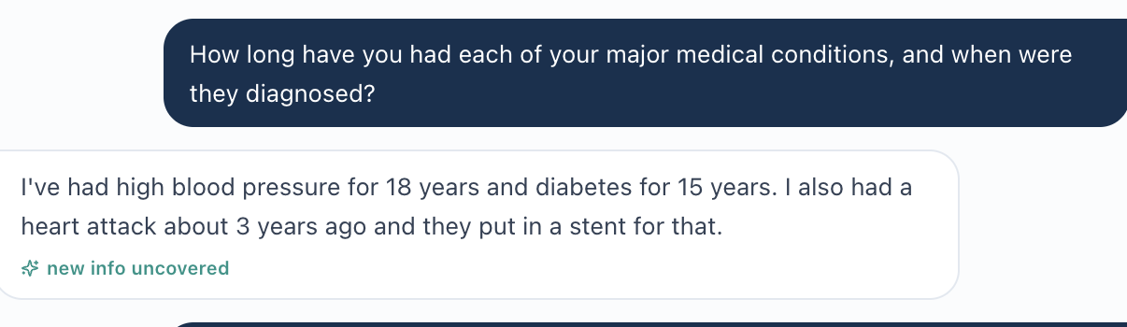
AI patient reports a heart attack about 3 years ago with a stent, without naming a drug-eluting stent.
AI grader separately requires the DES subtype.
Longitudinal verification note: Tuesday’s supplied LM export does include PCI/DES detail. This follow-up finding concerns whether that history is available in the current workflow; confirm whether students can access prior encounters before treating it as unavailable across the entire case.

Cross-Visit Patterns
Encounter stages and current summaries are not consistently refreshed. MG Wednesday/Thursday and JW/LM follow-up exports retain initial-visit wording. JW and LM also retain baseline problem summaries beside improved current panels. Confirm whether the entries are current or intentionally historical; label historical data clearly.
Allergy states conflict in all three LM exports. The detailed penicillin allergy is incompatible with “NKDA — no conflicts” in the medication checker. Live verification should establish whether the checker is actually using the wrong allergy state or displaying a stale label.
Recorded patient responses can disagree with hidden grading facts. Examples include LM former-smoking history on every day, home monitoring frequency, MG satisfaction and fatigue severity, and unreported patient goals or beliefs. Distinguish an interview gap from contradictory scoring of an answer that was actually obtained.
Clinical grading rules need current, context-sensitive logic. The source findings question a fixed statin dose, post-dose-change lipid timing, and the pneumococcal age threshold. The three clinical references were checked for this consolidation; student-specific judgment should remain tied to the case evidence.
Feedback can contradict the scoring decision. JW Tuesday’s affordability deduction conflicts with the documented primary barrier and the grader’s own Strengths narrative. Preserve the exact submitted note/payload in a controlled retest.
Evidence confidence varies. Live EMR screenshots and complete weighted master rubrics were not supplied as independent source files. The report preserves export and interview limitations rather than treating every source finding as a reproduced live defect.

Recommended Fix Order
1. Verify and synchronize the LM allergy record and medication-checker state first.
2. Establish one versioned Patient + Day dataset for encounter labels, current values, problem summaries, AI-patient memory, advisories, and the grading reference. Preserve prior values only as explicitly labeled history.
3. Align objective values and source labels: home BP, sodium, UACR trends, cardiovascular-history flags, and the BSA calculation. Do not penalize faithful transcription of the displayed result.
4. Align elicitable subjective history with grading expectations. Use neutral questions to test required monitoring frequencies, symptom severity, goals, concerns, and understanding. Surface any required longitudinal history.
5. Update clinical-reference criteria for supported statin intensity, post-change versus stable lipid monitoring, and current pneumococcal vaccination eligibility.
6. Retest scoring consistency using the exact submitted SOAP text and full returned feedback, particularly JW Tuesday affordability scoring.
7. Complete all nine encounters end to end after fixes. Confirm that every remaining deduction concerns information the student could obtain and that interview omissions are described accurately.

Routine Documentation Items Excluded
The report excludes ordinary requests for fuller ROS, demographic/setting detail, numerical targets, guideline citations, medication counseling, named agents/doses, monitoring intervals, lifestyle targets, and definite follow-up plans unless the source shows a data or grading conflict. Missing answers that were not elicited—such as MG Wednesday injectable preference or unasked orthopnea/PND—remain interview/documentation opportunities. Unreported patient facts should not be inserted to satisfy grading.

Source and Evidence Notes
The Week 3 sample guides the report structure, glossary, encounter summaries, finding comparisons, evidence presentation, cross-visit patterns, and fix order. Its Week 3 patient facts, counts, and grader results are not transferred into this Week 1 report.
Nine initial audit reports and nine corresponding EMR Word exports were reviewed. MG Tuesday’s alternate layout, its 84% score, and all three issues were included. Source evidence images are preserved from the initial audits and remain under the related findings.
Only interview and AI-grader captures are included as screenshot evidence. Seven LM Thursday images rendered from an EMR Word copy are omitted to follow the Week 3 sample’s evidence approach. The underlying export findings remain as text with live-verification limitations. No new live capture, case reset, backend cause, or successful fix is inferred.
Some source reports refer to SOAP text and checklists preserved in the original audit conversation. Those are treated as source-report assertions, not independently verified raw submission payloads or complete master rubrics. JW Tuesday affordability scoring and other payload-sensitive deductions require a controlled retest. Source reference IDs and raw point deductions are preserved where supplied.
The report creation date is October 6, 2026. Source audit dates and dates embedded in the simulation are historical context; Tuesday/Wednesday/Thursday represent the supplied visit sequence. LM remains labeled First Follow-Up and Final Follow-Up because those are its supplied encounter labels.
Visit | Initial audit source | EMR export source
MG Tuesday | MG_Tuesday_Matched_Report(2).docx | MG 04 Tuesday EMR 10-1.docx
MG Wednesday | 02 MG Wed Initial Report(3).docx | MG 05 Wed EMR 10-1.docx
MG Thursday | 03 MG Th Initial Report(3).docx | MG 06 Th EMR.docx
JW Tuesday | 04 JW Tue Initial Report(3).docx | JW 01 Tue EMR.docx
JW Wednesday | 05 JW Wed Initial Report(3).docx | JW 02 Wed EMR.docx
JW Thursday | 06 JW Th Initial Report(3).docx | JW 03 Thur EMR.docx
LM Tuesday | 07 LM Tue Initial Report(3).docx | LM 07 Tue EMR.docx
LM Wednesday | 08 LM Wed Initial Report(2).docx | LM 08 Wed EMR.docx
LM Thursday | 09 LM Th Initial Report(2).docx | LM 09 Thur EMR.docx

Clinical References
[1] American Diabetes Association Professional Practice Committee for Diabetes. Cardiovascular Disease and Risk Management: Standards of Care in Diabetes—2026. Diabetes Care. 2026;49(Suppl 1):S216–S245. Recommendations 10.17 and 10.20; Table 10.1. Checked October 6, 2026.
https://doi.org/10.2337/dc26-S010
[2] Centers for Disease Control and Prevention. Pneumococcal Vaccine Recommendations. Page dated February 25, 2026. Adult vaccination section. Checked October 6, 2026.
https://www.cdc.gov/pneumococcal/hcp/vaccine-recommendations/index.html

